2015-AT-01-Super Power Family
0 ---- | I: hard | II: medium | III: medium | IV: easy

Answer Type: Multiple Choice Graphics are: self made and colorblind proof

Body
In a beaver family all family members have abilities. A daughter inherits all abilities from her mother; a son inherits all abilities from his father. In addition to the inherited abilities, each family member also has one additional ability. The diagram below shows the relationships between the beavers. It also shows for each beaver the additional ability.

In the picture you can see that Mother Jennifer has inherited the ability to sing from grandmother Maria, and in addition to that she has the ability to program. Lisa inherits from her mother both these abilities, and adds the ability of writing. So she has the ability to write, program and sing.

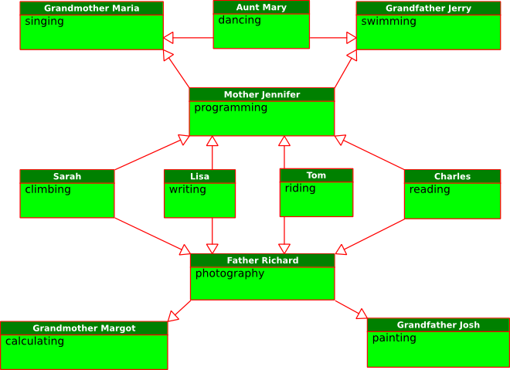

Question

Which statement is correct?

- Sarah has abilities in reading, programming and singing.
- Tom inherits from Grandmother Margot the ability to calculate.
- Aunt Mary has abilities in dancing and swimming.
- Tom’s abilities are riding, painting and photography.

Answer

Statement 4 is correct, since Tom inherits painting from his grandfather and photography form his father.
Statement 1 is not correct, because Sarah does not inherit reading from her brother Charles.
Statement 2 is not correct, because Tom can not inherit abilities from his grandmother.
Statement 3 is not correct, because Aunt Mary does not inherit swimming from her father.

Explanation

It's informatics

Inheritance is an important concept of object oriented programming. Parts of software systems can be reused and expanded. In this case abilities are like parts of software and are inherited and enriched with additional abilities. In our task inheritance is different from programming because not everything is inherited.

Keywords

Programming, object orientation, inheritance

Websites

http://en.wikipedia.org/wiki/Inheritance_(object-oriented_programming)

Internal Use

Wording

Comments

The names of the family can/should be adapted to common names of a specific country.
Adil edited the image to show the inheritance with standard UML notation.
Adil and Willem changed the introduction.
Eljakim changed the wording.
This file has a .png-image, but an .svg-graphic is also available.

Files

2015-AT-01-Super Power Family.svg (graphic)
2015-AT-01-Super Power Family02.odt(this file)

Authorship

Elisabeth Oberhauser, elisabeth.aisha.oberhauser@gmail.com, Austria, Author
Andreas Athanasiadis, andi.athanasiadis@gmail.com, Austria, Adaptions + formatting

License

Copyright © Bebras – International Contest on Informatics and Computer Fluency.
This work is licensed under a Creative Commons Attribution-ShareAlike 3.0 Unported License. Visit: http://creativecommons.org/licenses/by-sa/3.0/

